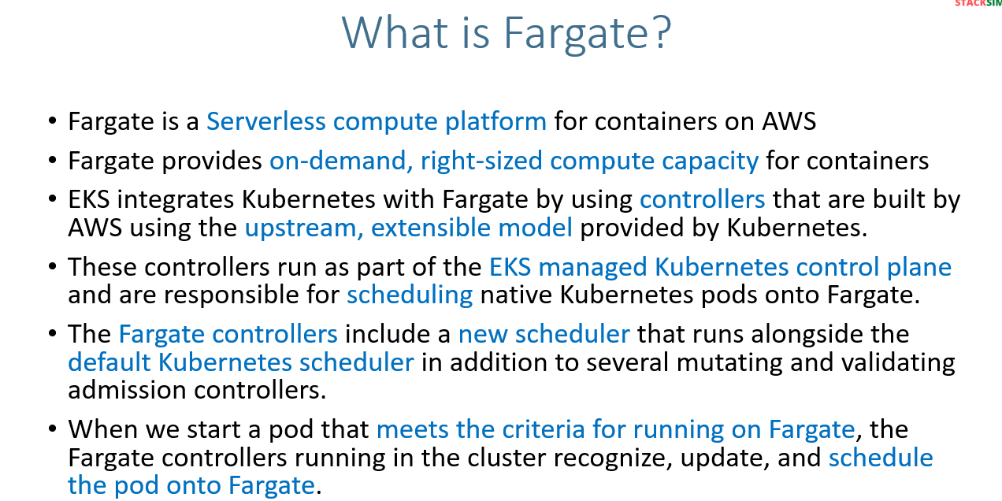
The key point is in the managed Kubernetes control plane we have Fargate controllers which is built using upstream, extensible model provided by Kubernetes for scheduling the PODs.
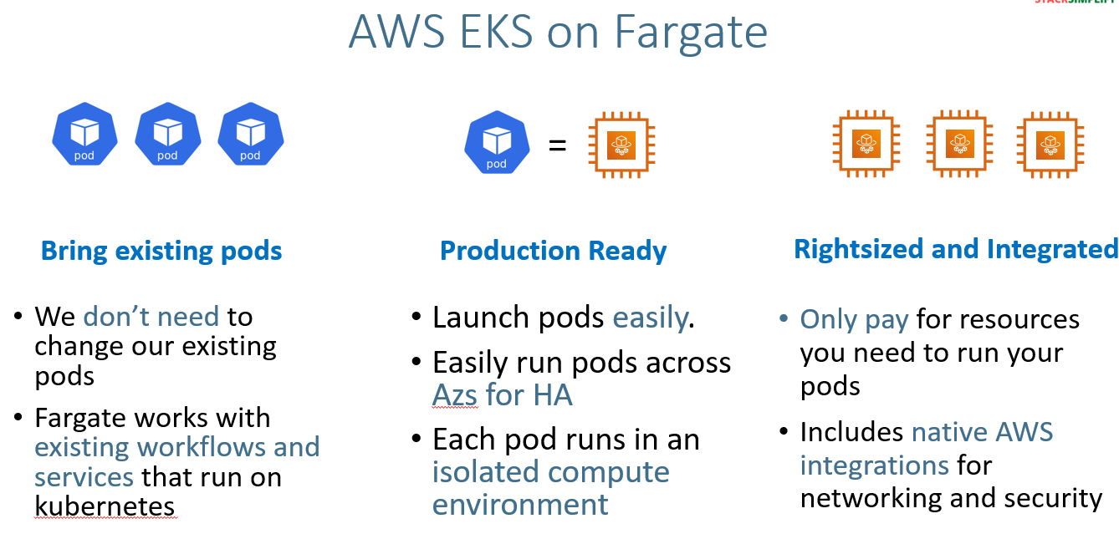
Note:- 1 POD= 1 ec2 fargate instance
Eg: if you deploy 5 pods you can see 5 ec2 farget instance.
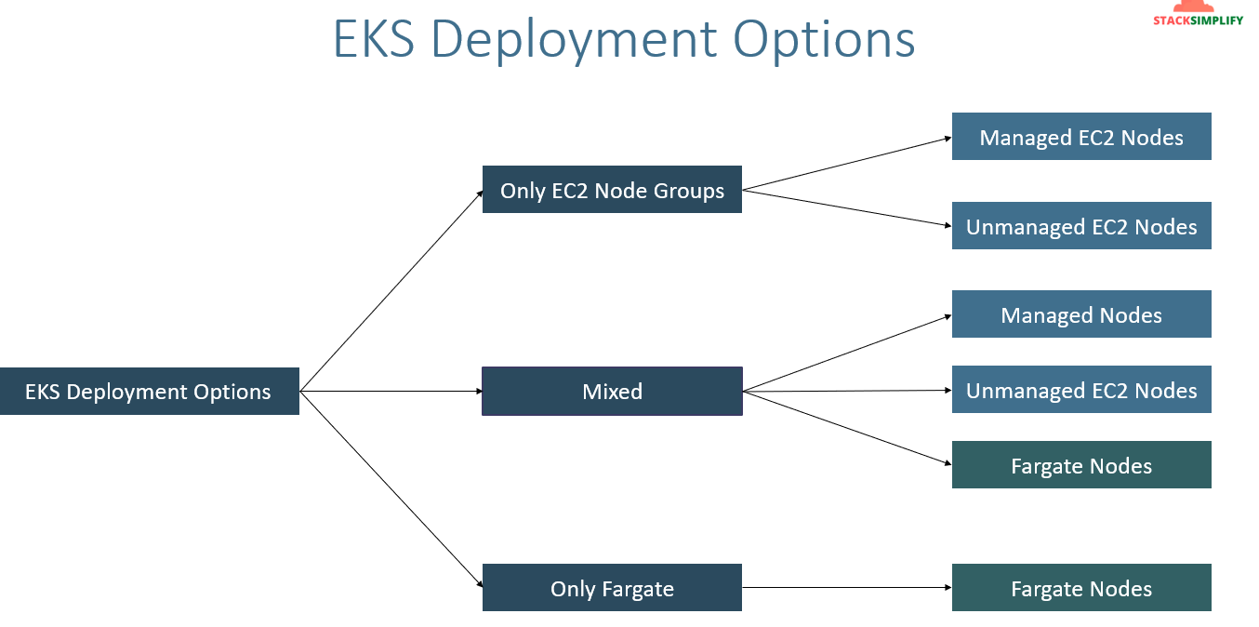
Only Ec2 node group:-
Here, you can plae our node groups either in public subnet or in private subnet inside the EKS clsuter’s VPC. 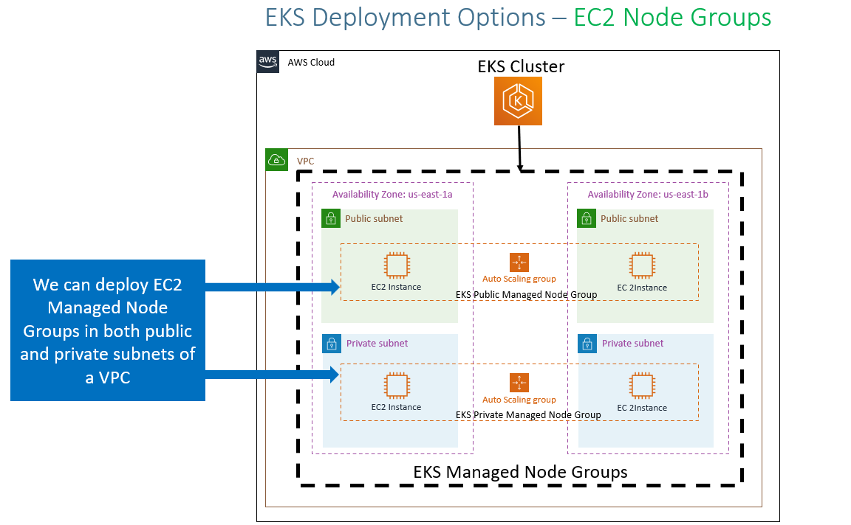
Only Fargate:- The Fargate severless should placed in only private subnet.
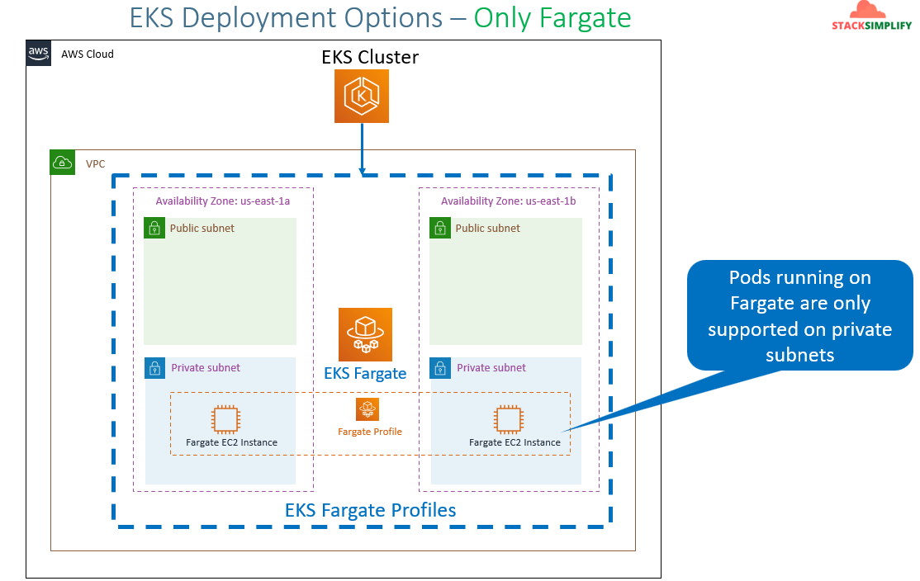
Mixed mode:- 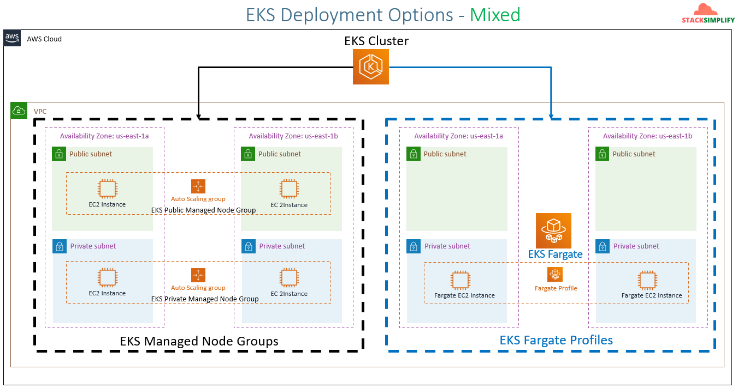
Comparison of Fargate, managed node & unmanaged nodes:-
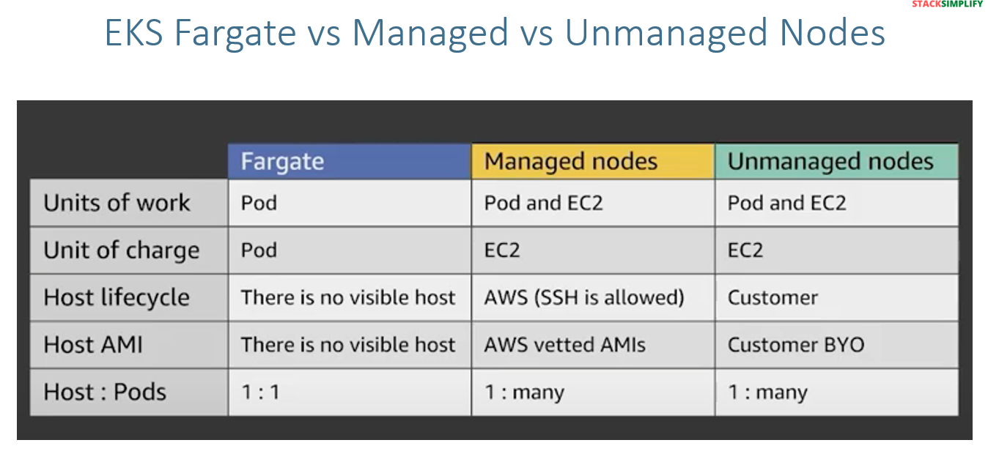
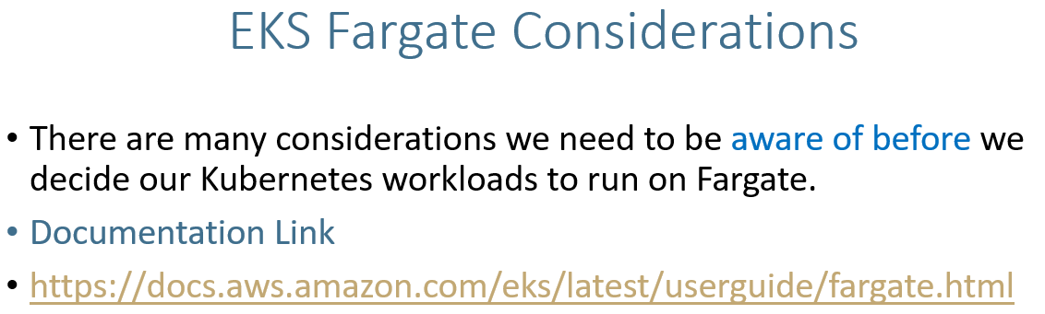
Simplify compute management with AWS Fargate - Amazon EKS
Visit the link and check the consideration. While you opt for fargate you need to check the fargate considerations.

Eg:-
- Network Load Balancers and Application Load Balancers (ALBs) can be used with Fargate with IP targets only. For more information, see Create a network load balancer and Route application and HTTP traffic with Application Load Balancers.
- Daemonsets aren’t supported on Fargate. If your application requires a daemon, reconfigure that daemon to run as a sidecar container in your Pods.

There are lot of considerations are there. So, please go through this link Simplify compute management with AWS Fargate - Amazon EKS .

Fargate Basics:-
Note:- Fargate profile can be deployed when we have at least one private subnet.
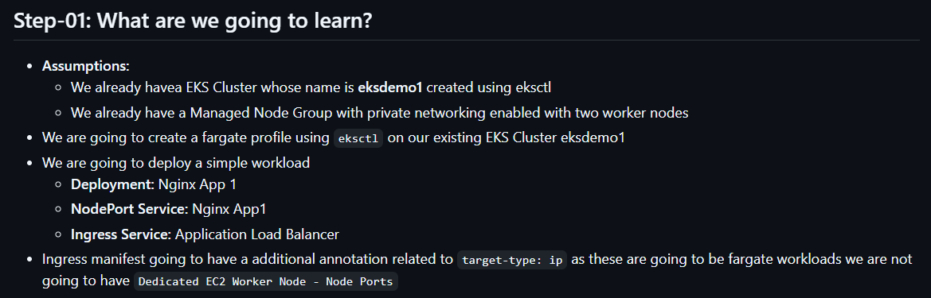
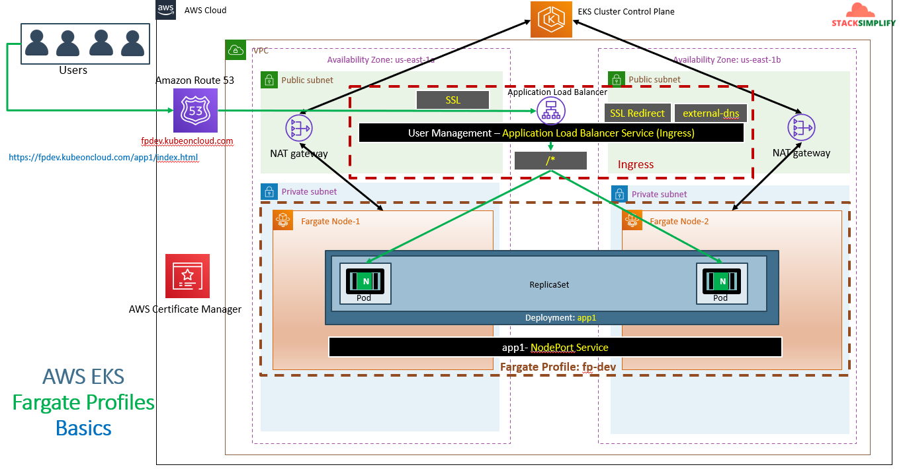

Hands On:-
While creating fargate we need to define the namespace. Whatever the PODs you deploy to fargate those can be deployed in that defined NS. Here our NS is ‘fp-dev’.
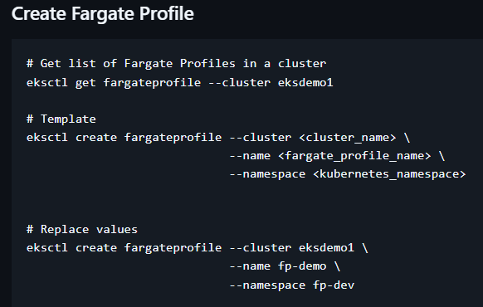
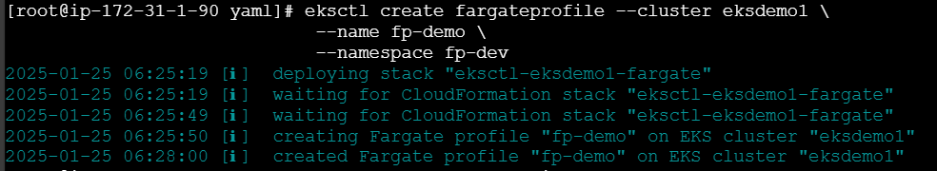
List the fargate
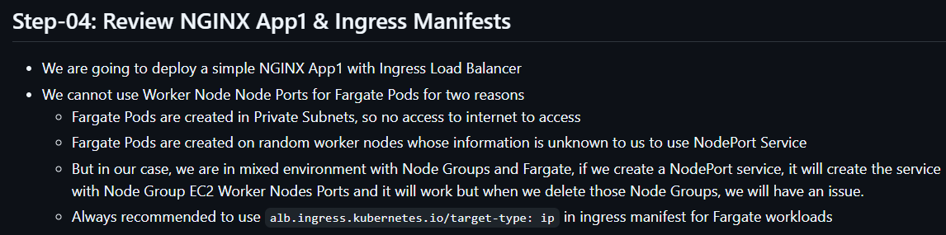
Create a namespace:-
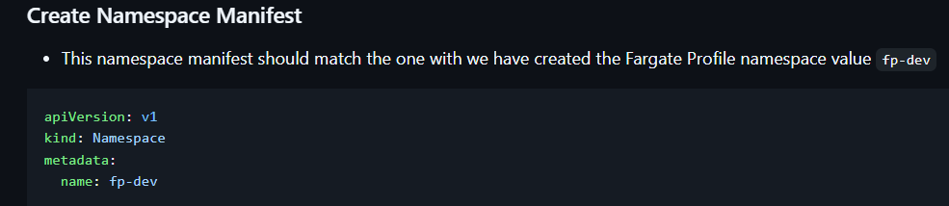
Now, we are going to mention the fargate name in all the manisfests like deployment,service and ingress.
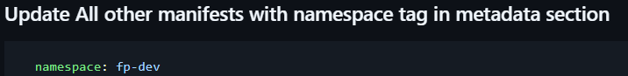
Like below
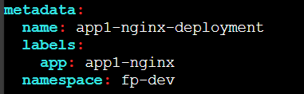
It’s necessary to define the requests & limits about cpu and memory.
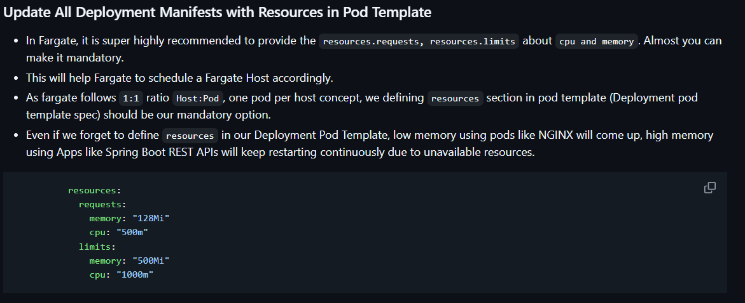
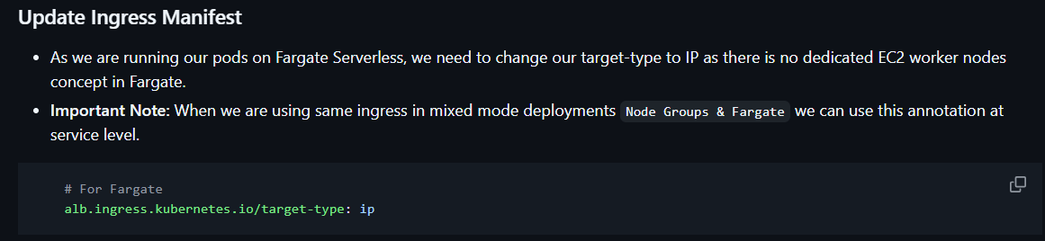
List the fargate pods
Each pod has separate ec2 fargate node got created.
And, number of nodes will be 3. 2 Fargate and 1 node.
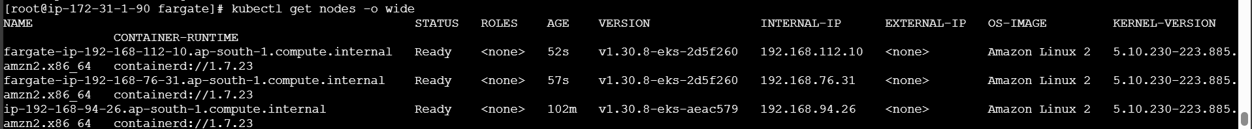

We have 2 registered targets under our target group.
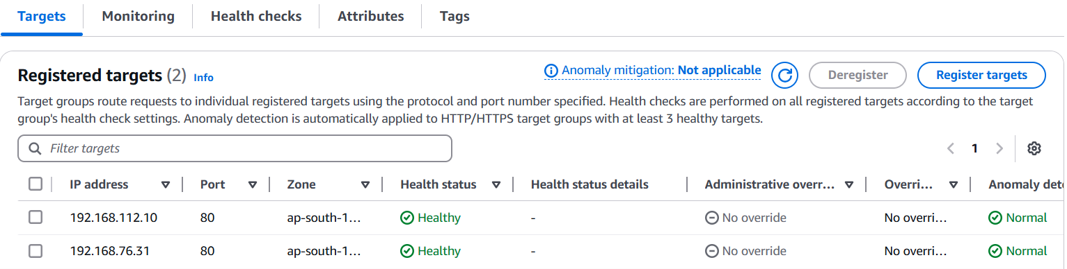
Now, let’s delete the fargate profile.
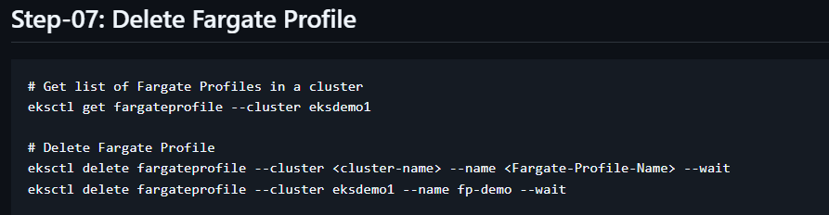
‘--wait’ will wait until our fargate profile will get deleted.
The fargate profile got deleted but whatever PODs running on fargate profile got moved to nodegroup you can see in above SS.
Before it was
And, still the application will be up and running.
The above are basics, If you want more refer to below links.
- https://eksctl.io/usage/fargate-support/
- https://docs.aws.amazon.com/eks/latest/userguide/fargate.html
- https://kubernetes-sigs.github.io/aws-alb-ingress-controller/guide/ingress/annotation/#annotations
- https://kubernetes-sigs.github.io/aws-alb-ingress-controller/guide/ingress/annotation/#traffic-routing
EKS Fargate- Mixed mode intro (Advanced with YAML):-
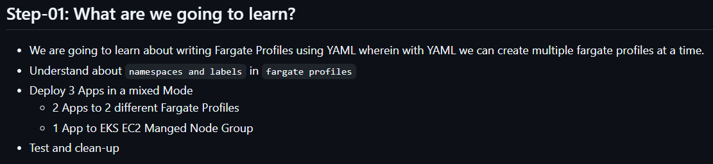
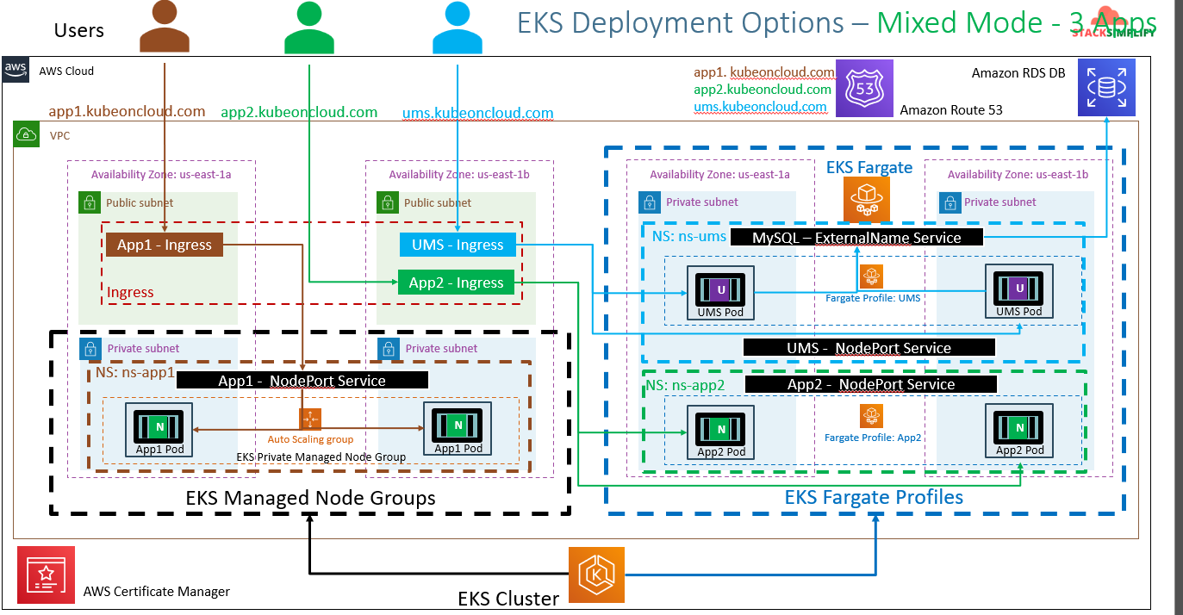
- If you see above SS. We have used 3 Apps 2 are using 2 fargate profiles and another app is using managed node groups.
- Each app is having separate ingress resources.
- In previous sessions we have used context path based routing but here we can’t use it.
Why One Ingress for all the apps won’t work:-
The Ingress with cross namespace is not supported as on today. That feature is not there in EKS.
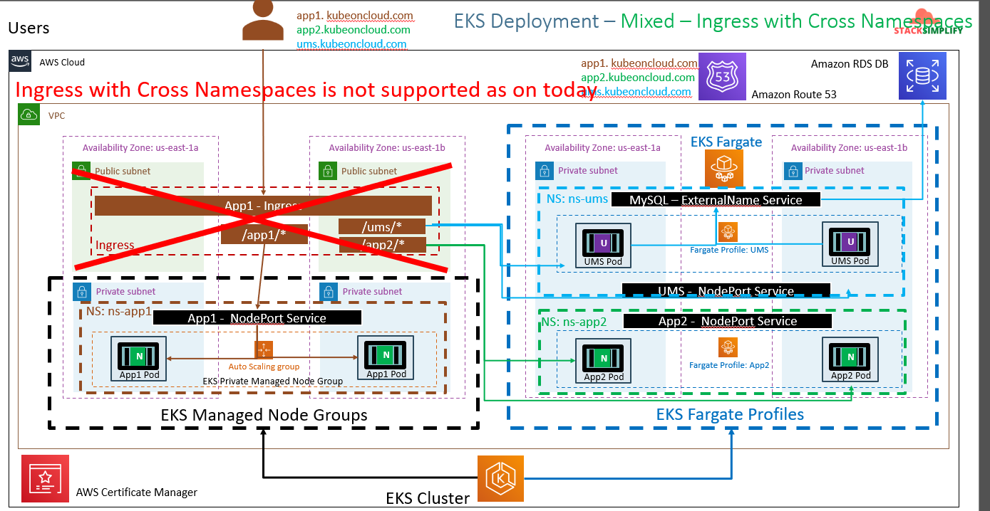
So, within the NS you can do multiple context path based routing but across the NS it’s not supported.
Hands on fargate profile using yaml :-
Write the fargate profile manifest
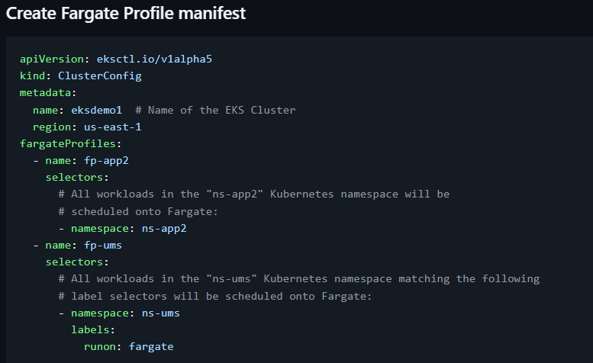
If you see metadata, it’s not normal metadata. There we are defining the cluster name and region of the cluster.
Under fargate profiles, we have defined 2 NS. Whatever that particular NS PODs get deployed those will be assigned to respective fargate profile.
Eg: ns-app2 NS PODs will be assigned to fp-app2 Fargate profile. If label ‘fargate’ and NS ns-ums both matches then the POD will be running on fp-ums.
Once script is ready run the script with this command “eksctl create fargateprofile -f kube-manifests/01-Fargate-Advanced-Profiles/01-fargate-profiles.yml”.
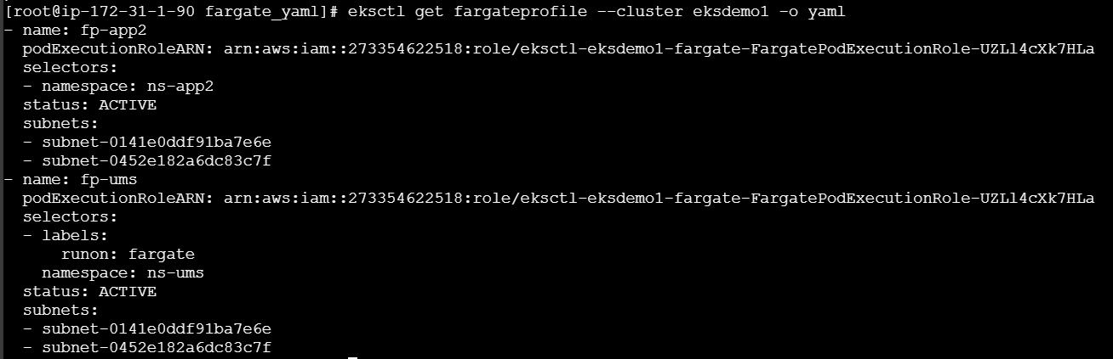
Here, I’m not going to deploy the all the apps as mentioned in network diagram. Because it requires RDS should be running. Instead I’ll be explaining the each app script.
App1:- Everything will be normal extra we will create the NS using NS script.
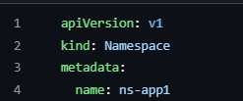
The NS script is common for all NS. only NS name will change. Now, we will define the NS details in deployment, service & ingress script. Since App1 will be using node group we won’t define the mode type.
App2:-
NS will be same. NS name need to define in Deployment, Service & Ingress.
Extra we need to define the mode. This time we are defining the mode in service manifest not in ingress manifest.
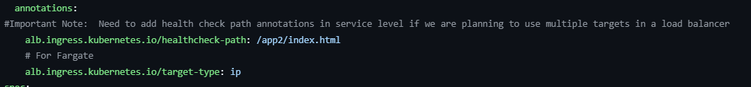
Extra we are defining this in Ingress.
Note:- Tutor has mentioned the target-type in ingress script and in service script. Need to check.
App3:-
NS will be same. NS name need to define in Deployment, Service & Ingress.
We need to define node-port as ip and have few other scripts related to App.Please check this link aws-eks-kubernetes-masterclass/09-EKS-Workloads-on-Fargate/09-02-Fargate-Profiles-Advanced-YAML/kube-manifests-old/02-Applications/03-ns-ums at master · stacksimplify/aws-eks-kubernetes-masterclass .
Once you run the command it will create 3 NS. Verify how many nodes got created for fargate and node group. It will create 3 ALBs with 3 TGs. Verify it should create total 6 DNS records. Do check NSlookup.
Note:- Whenever you create a workload on fargate profile it will take sometime because it doesn’t have node it will create a node and then it will install the kubelet inside that and the kubelet need to register to control plane and then will check for the scheduler and get the data and then will create the POD. This delay will same for delete. Delay is not for performance.
- Issue related cross NS you can see here kubernetes/kubernetes#17088

